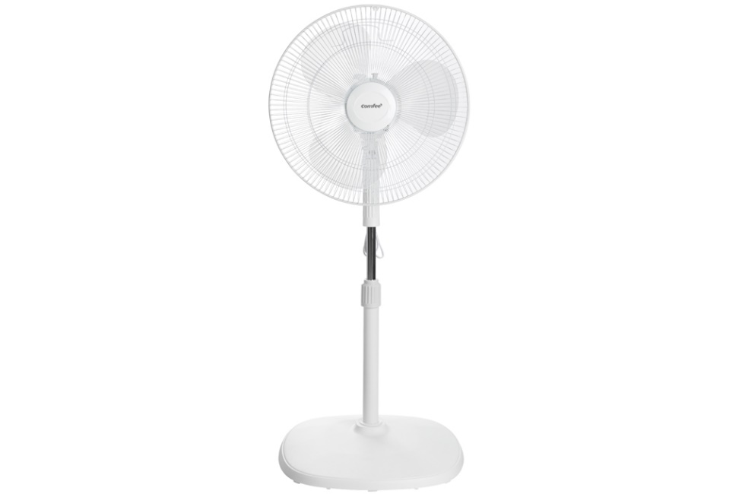

**450,000 VND**

~~710,000 VND~~ -36%

**Technical specifications Comfee 3-blade fan CF-FF4019VEW 48W**

* Fan Type:

[Mezzanine fan](https://www.dienmayxanh.com/kinh-nghiem-hay/cac-loai-quat-pho-bien-tren-thi-truong-845793#quat-lung) - 48W - 3 wind levels

* Fan diameter:

3 wings - 40 cm

* Wind mode:

Normal wind

* Dashboard:

Rotate button

* Motor type:

Silver brazing

* Utilities:

The fan cage has a small fan blade gap, height adjustable

* Size, volume:

Width 45 cm - Height 93 - 105.5 cm - Depth 43.7 cm - Weight 3.5 kg

* Brand of:

IDEA

* Launch year:

2019

Introducing the company 

- Comfee is a brand from Italy, fans are made in Vietnam, air conditioner fans are made in China.

- Established in 2009.

- Comfee branded household electrical products have advanced technology along with high craftsmanship through a creative process to improve your family's living space, bringing families around the world a more comfortable life. .

[**Comfee fan**](https://www.dienmayxanh.com/quat-comfee)**belongs to the electromechanical fan line with beautiful bright white color, sturdy design, large base, guaranteed to stand firmly on floors.**

[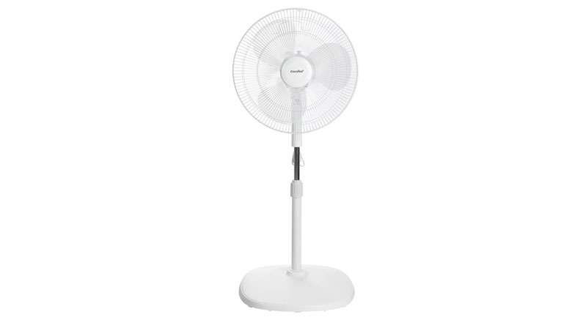](https://cdn.tgdd.vn/Products/Images/1992/218463/quat-lung-comfee-cf-ff4019vew-trang-3-1.jpg)

**There are 3 fan blades with a diameter of 40 cm combined with a capacity of 48W capable of creating strong airflow to cool any room space.**

[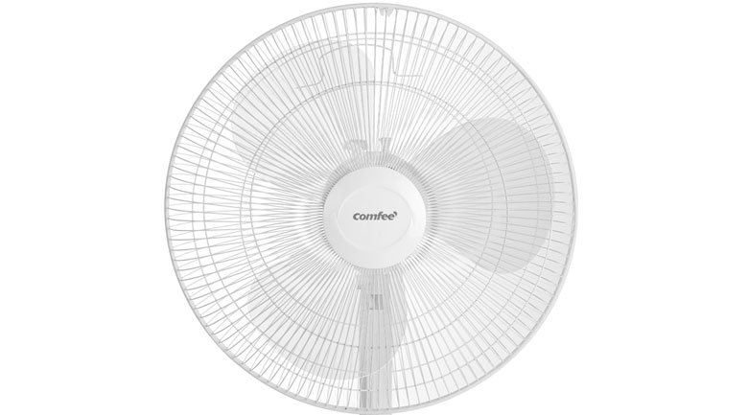](https://cdn.tgdd.vn/Products/Images/1992/218463/quat-lung-comfee-cf-ff4019vew-trang-5-1.jpg)

**Use the rotary knob control to customize 3 flexible wind speeds**

In addition, the fan also has a button located near the speed adjustment knob to adjust the fan's rotation function.

**The mezzanine**[**fan cage**](https://www.dienmayxanh.com/quat?g=quat-lung)**has a neat and sturdy design, the spokes are tightly woven, thus limiting the dangers of close contact with the fan.**

The fan cage is removable, [convenient to clean](https://www.dienmayxanh.com/kinh-nghiem-hay/huong-dan-cach-ve-sinh-quat-lung-535900) .

[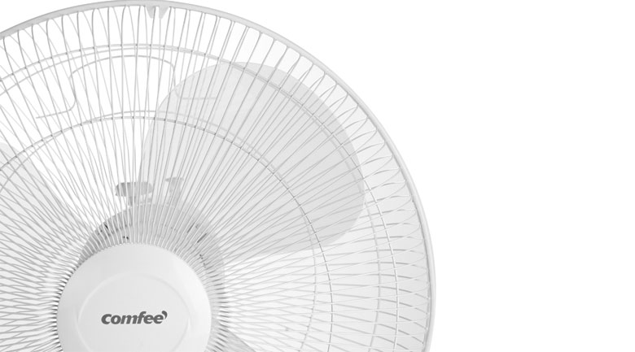](https://cdn.tgdd.vn/Products/Images/1992/218463/quat-lung-comfee-cf-ff4019vew-trang-1-2.jpg)

[**The fan**](https://www.dienmayxanh.com/quat)**can easily change the height from 93 - 105.5 cm, the power cord is up to 150 cm long, meeting the cooling needs in many different usage situations.**

**Tips for using mezzanine fans effectively**

- Do not place the fan near high heat sources or water sources to avoid reducing the durability of the product.

- When stopping use, you should turn off the fan and unplug the fan from the electrical outlet.

- Clean the fan blades and fan body periodically to increase cooling efficiency.

[Comfee CF-FF4019VEW mezzanine fan White](https://www.dienmayxanh.com/quat/quat-lung-comfee-cf-ff4019vew-trang) , modern cooling product, simple, beautiful design, easy to use, good cooling, the product will be a suitable cooling choice for your family.